Courtney Thurston

AP Art History

Mrs. Eckel

U3L10 Unit Assessment

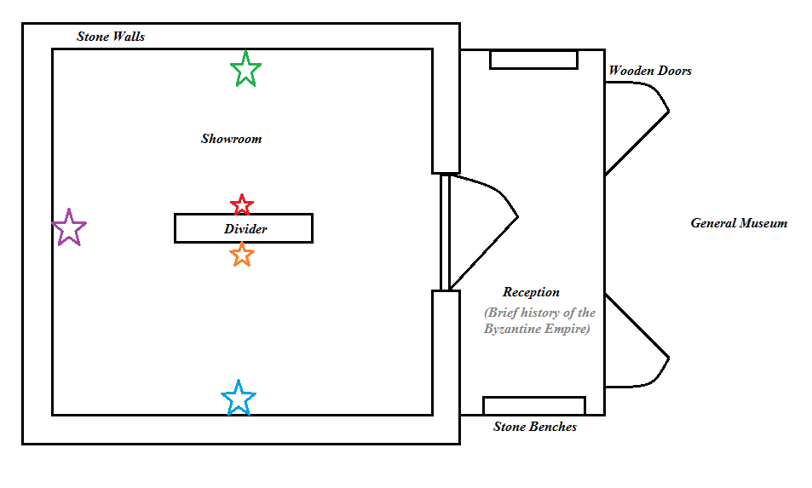

*What is the focus of your selected works of art that are displayed? Why?*

The focus of my selected works is on the Byzantine period of Art as I am personally fascinated with that style and have created some of my own religious icons based on the opulent mosaics from the Byzantine Empire.

The selected works are as follows:

* Red Star: Mosaic Cross Ravenna I
* Orange Star: Rabula Gospel Miniature
* Blue Star: Fresco of Nerezi
* Green Star: Justinian I Mosaic (San Vitale)
* Purple Star: Theodora and Servants Mosaic

*What architectural style of building will be appropriate and representative for your collection of artwork? Why? Explain your building design choice and how the architectural form follows the function of your building.*

The architectural style of the wing that I chose to create is quite simple in an effort to contrast with the opulent nature of the Byzantine art work featured. Stone is used throughout as it is rather simple and reminiscent of the materials available and used in architecture during the Byzantine Period, and the benches provide rest for weary museum-goers. Meanwhile, the divider wall is utilized to keep the display interesting by dividing the space, though the roof of the room will be fifty feet high with one large-pane window at the top—spanning each wall—in an effort to increase the natural light in the room. This architectural style was inspired by a real-life museum near me, the Brandywine Museum, which utilizes a similar room structure to show its more decorated and complicated pieces of art (such as mosaics).